X and Y Coordinates-Answers
Key Stage 3: 2003 Paper 1 Level 3-5
1.
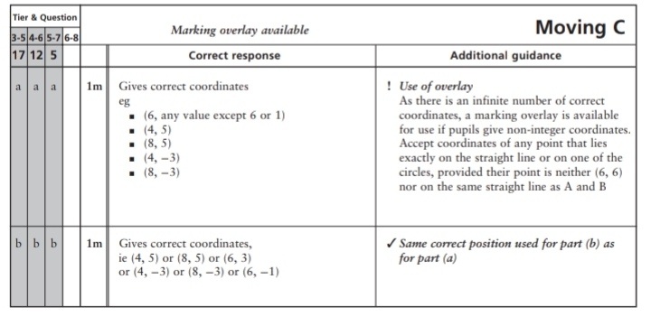
Key Stage 3: 2003 Paper 1 Level 4-6
2.
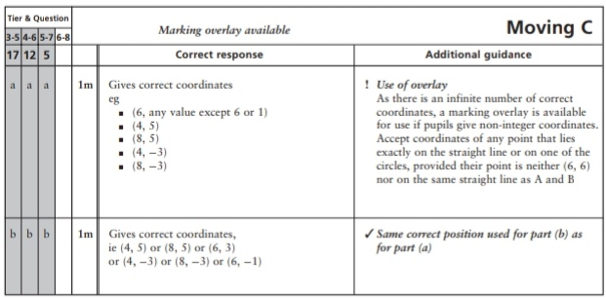
Key Stage 3: 2004 Paper 2 Level 3-5
3.
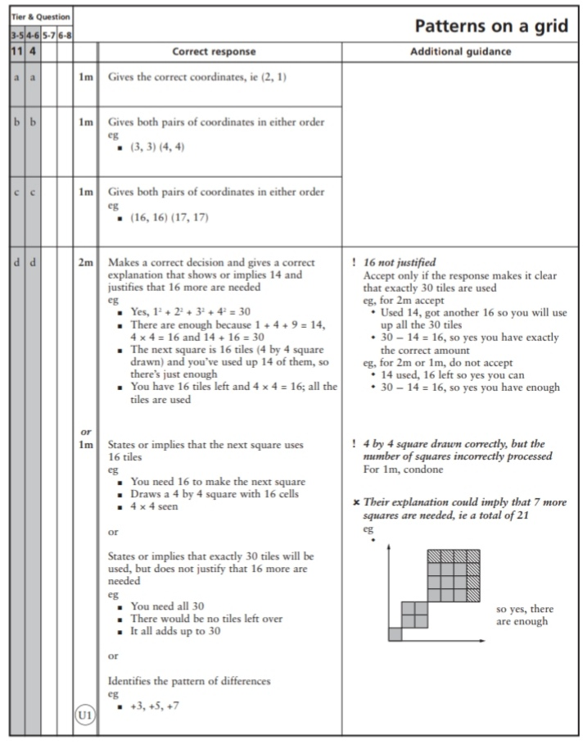
Key Stage 3: 2004 Paper 2 Level 4-6
4.
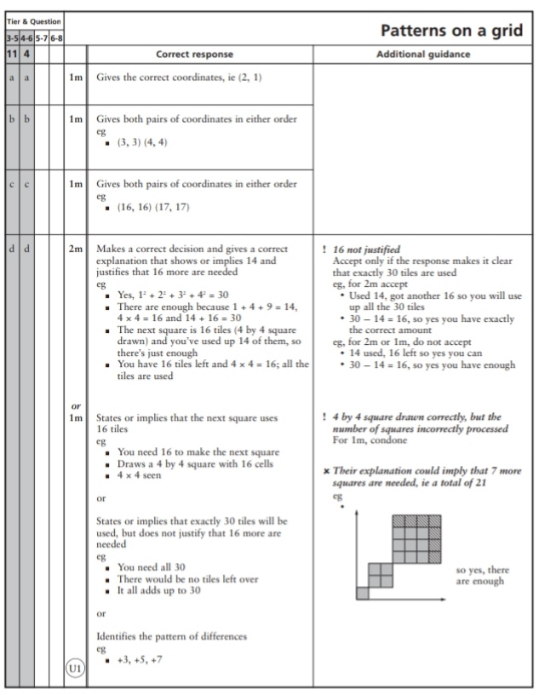
Key Stage 3: 2005 Paper 1 Level 3-5
5.
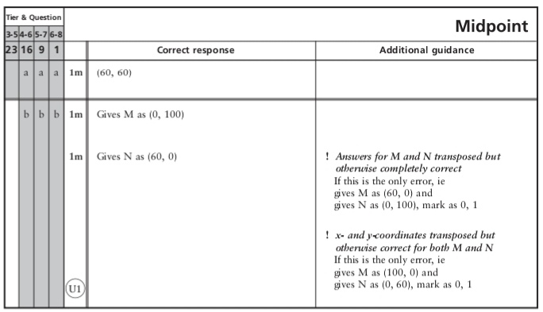
Key Stage 3: 2005 Paper 1 Level 4-6
6.
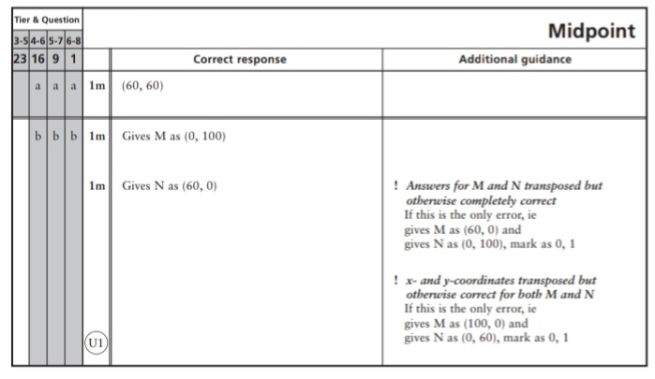
Key Stage 3: 2007 Paper 2 Level 3-5
7.
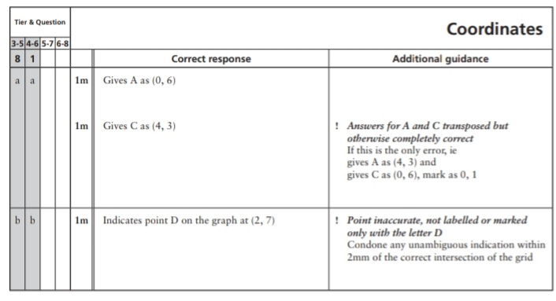
Key Stage 3: 2007 Paper 2 Level 4-6
8.
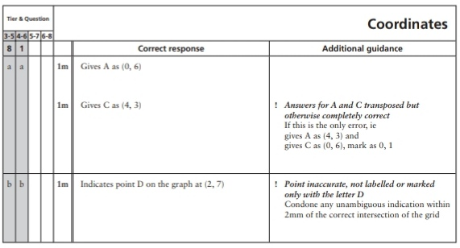
Key Stage 3: 2008 Paper 1 Level 3-5
9.
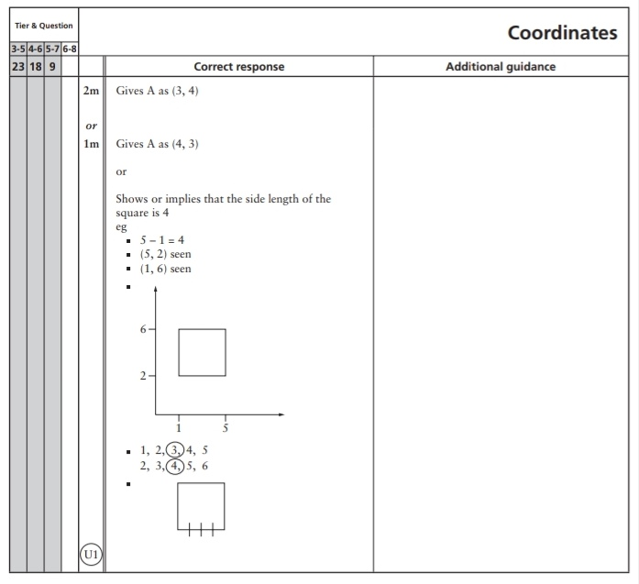
Key Stage 3: 2008 Paper 1 Level 4-6
10.
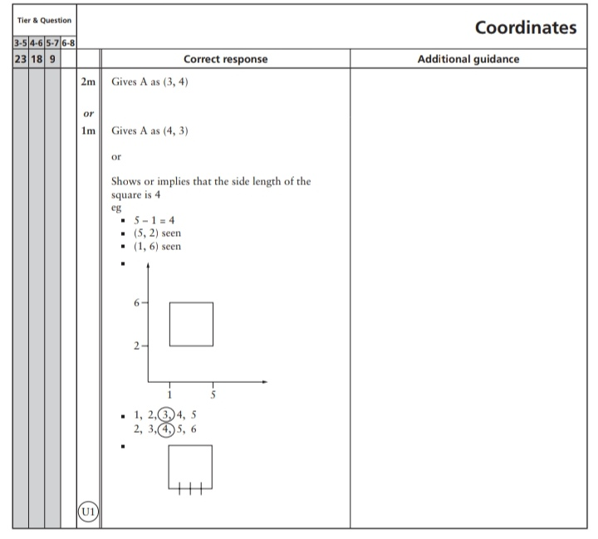
Key Stage 3: 2009 Paper 2 Level 4-6
11.
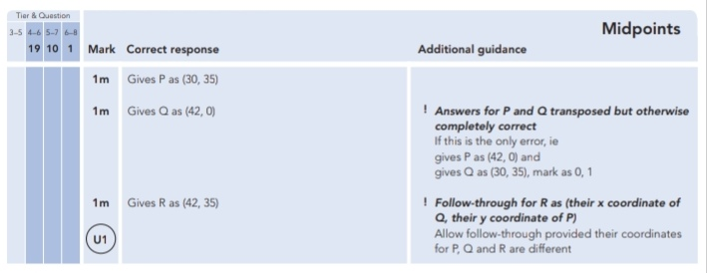
Key Stage 3: 2010 Paper 1 Level 3-5
12.
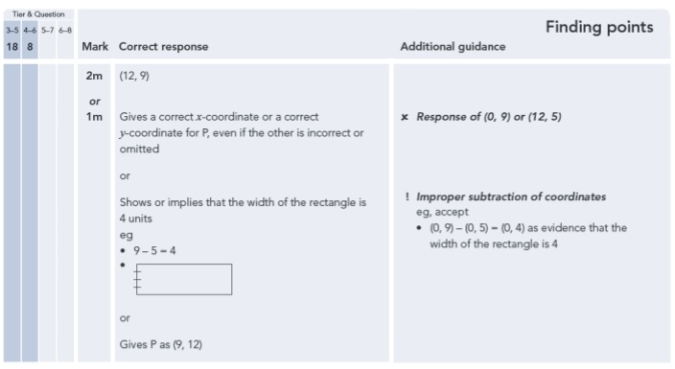
Key Stage 3: 2010 Paper 1 Level 4-6
13.

